Autonomous robotic car and arm
Alexander King

1 COMPONENT LIST & PURCHASED ITEMS
See Table 1 in the Appendix.

2 OUTSOURCED DESIGN/LIBRARY/SOFTWARE
See Table 2 in the Appendix.

3 MECHANICAL DESIGN AND FABRICATION

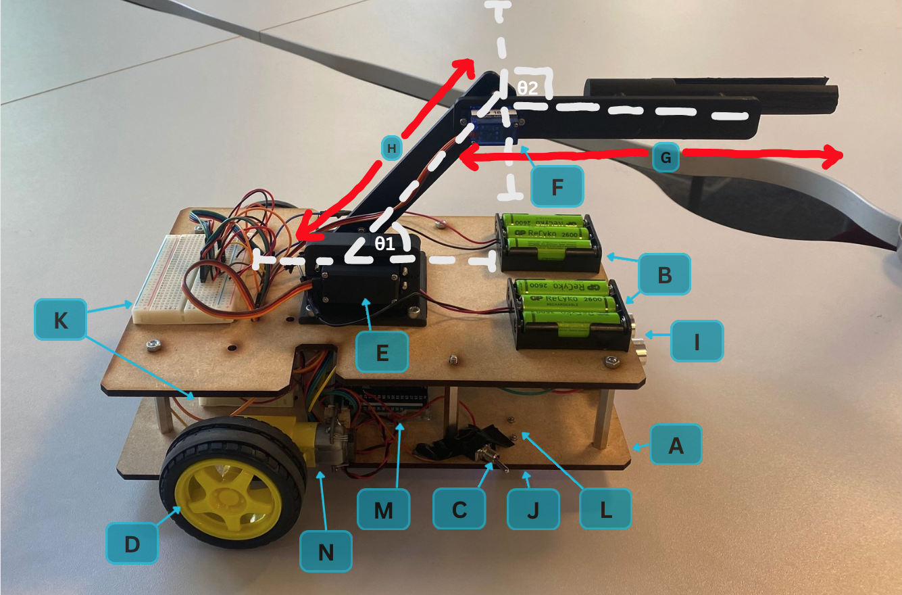
Fig. 1 The developed robot:

A: MDF Chassis
B: Battery holders / 6x 1,700mAh Batteries
C: Toggle Switch
D: Wheels (1 on each side)
E: Servo Motor (MG996R)
F: Servo Motor (SG90)
G: Arm L2
H: Arm L1
I: HC-SR04 Ultrasonic Sensor
J: TCS3200 Colour Sensor
K: Breadboards
L: Ball Casters (1 on each side)
M: Arduino Mega
N: FIT0450 Gear Motors (1 on each side)

Key mechanical aspects:
Chassis
We used an MDF laser cut chassis made up of two levels and held together by spacers. This material was chosen due to its low cost, ease of laser cutting and sturdiness. The flat layout of our chassis layers allow for easy mounting of electronics as well.
Motion
Using a combination of gear powered wheels and ball casters, our robot was able to move. This drive combination was chosen for its simplicity and ability to turn a full 360 on the spot (zero-radius turning). The gear motors allowed us to control the rotation speed (via a feedback loop to make sure both wheels rotated at the same speed).
Actuation
The main actuators are the motors used throughout. We used a combination of SG90 and MG996R servo motors as well as a FIT0450 Gear motor. Our servo motors allow for a working 2 DOF arm system. The MG996R has a higher torque so this was used as the base joint to carry the heavier load. The 2 wheel gear motors also use encoders to allow for accurate robot turns. The colour sensor also has an LED actuator which allows better visibility for colour sensing.
Sensing
We used an ultrasonic sensor and a colour sensor. The ultrasonic sensor was used to calculate the distance between the front of our robot and oncoming walls/obstacles. The colour sensor was used to identify the surface beneath the robot, which was used to determine when it left the yellow track at the start of the sequence and re-entered the yellow track at the end of the sequence.
Power
Our robot is powered by 6x1700mAh batteries which deliver enough voltage and current to run our motors and sensors. We placed the holders on the top for ease of access and replacement of batteries.
Circuit organisation
Our arduino mega is connected to 2 breadboards. The mega was a better fit than an uno because it gave us enough pins to accommodate for all actuators, sensors and switch pins. The breadboards were used for an ideal circuit layout with fast response times.

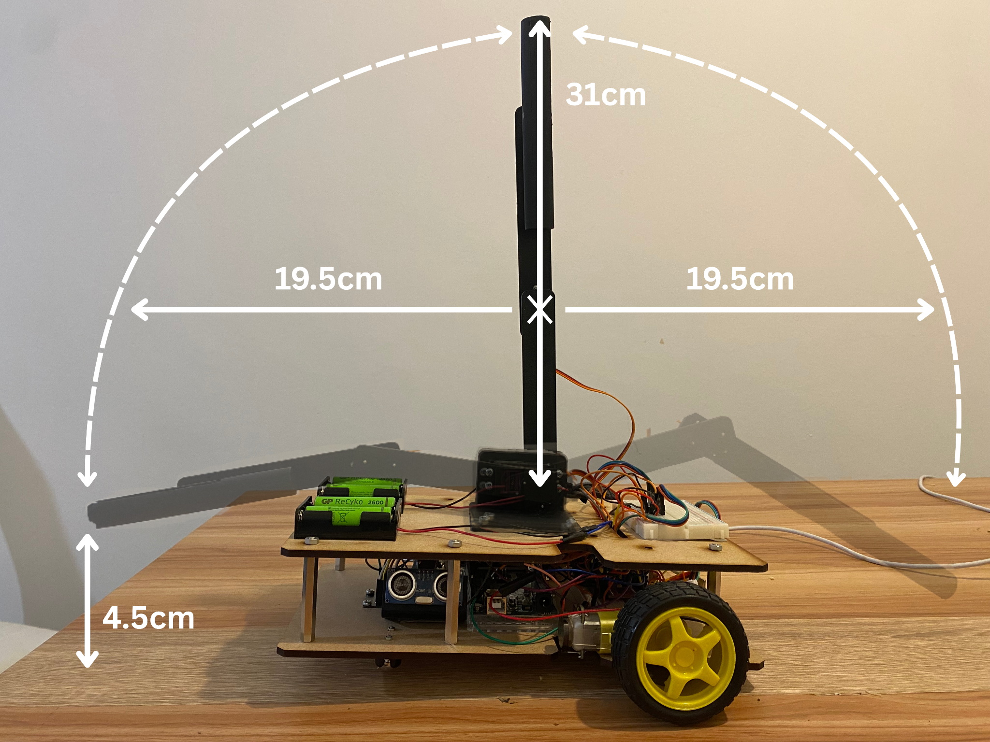
Fig. 2. The workspace of the robot arm. (example)

Carriable load of your arm:
Torque available = 1.8kgcm
Mass of elbow = ​​148g
Length of elbow to pen tip = 18cm
T = (0.148x9) + (Wx18)
W = 0.026kg = 26g

Stability
The centre of mass location are at the coordinates: (-115.03, 133.02)

Fabrication method, cycle time, sustainability
We used a MDF base as the material is cheap, sustainable, strong and easy to shape. We fixed the off-board components to the robot using a variety of screws and glue gun adhesives to ensure all components were secured.

We used a laser cutter to create the MDF chassis to ensure that the pieces were cut out precisely. For the robot arm and servo bracket we decided to 3d print the necessary parts as they were more intricate and detailed, so 3d printing ensured a high accuracy model with minimal use of excessive material, lowering manufacturing costs.

The robot took 3 weeks to manufacture and assemble in total, the slowest process was the 3d printing, for which each part had to be done overnight, but this was necessary to ensure the parts were created with a high accuracy, so they fit into the robot properly.

The sustainability of the robot was addressed as we used rechargeable batteries to power the circuit, reducing the robot’s consumption of raw earth metals such as zinc. We also used fixings that can be removed easily, either by unscrewing or being pulled apart, allowing the robot to be repaired without needing to be completely replaced.
Equipment
We used the university IForge laser cutter, 3d printer and glue gun to manufacture the robot. We wanted to automate the process as much as possible to minimise production error, reducing the number of models that we needed to make, speeding up and increasing the sustainability of the process.

4 ELECTRONICS
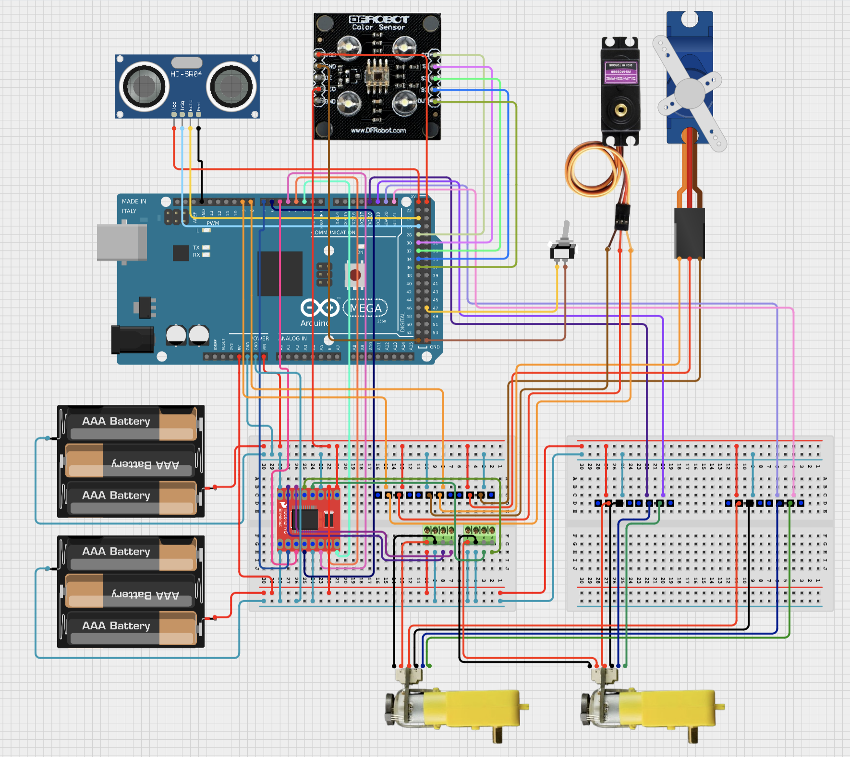
Fig. 3 Schematic of the electronic circuit

Microcontrollers:
Arduino Mega: we used an Arduino Mega instead of the smaller Arduino uno as we needed the extra input and output pins available to control all of the components of the robot.

Sensors:
Colour sensor: this was used to stop the robot in the yellow area for the pen drop.
Ultrasonic sensor: this was used to prevent the robot from colliding with the walls of the course.
Toggle switch: this was used to start and stop the code sequence.

Actuators:
Servo motors: these were used to control the robot arm and manipulate the pen.
gear motors: these controlled the robot wheels. colour sensor LED: this was used to ensure the components of the robot were powered and it helped the colour sensor differentiate the different colours of the course surface, increasing its accuracy.

Batteries and robot’s operation time
We used 6 rechargeable AA batteries to power the arduino circuit as they together provided enough power for the circuit components to work properly for the entire operational time.
.
Circuit board, wires and connectors
We used two breadboards to construct our circuit so that our component could be more spaced out, easing the wiring process. We also decided to use jumper wires as these stayed attached to the breadboard in a more reliable fashion compared to the standard wires used for previous projects.

5 CONTROL
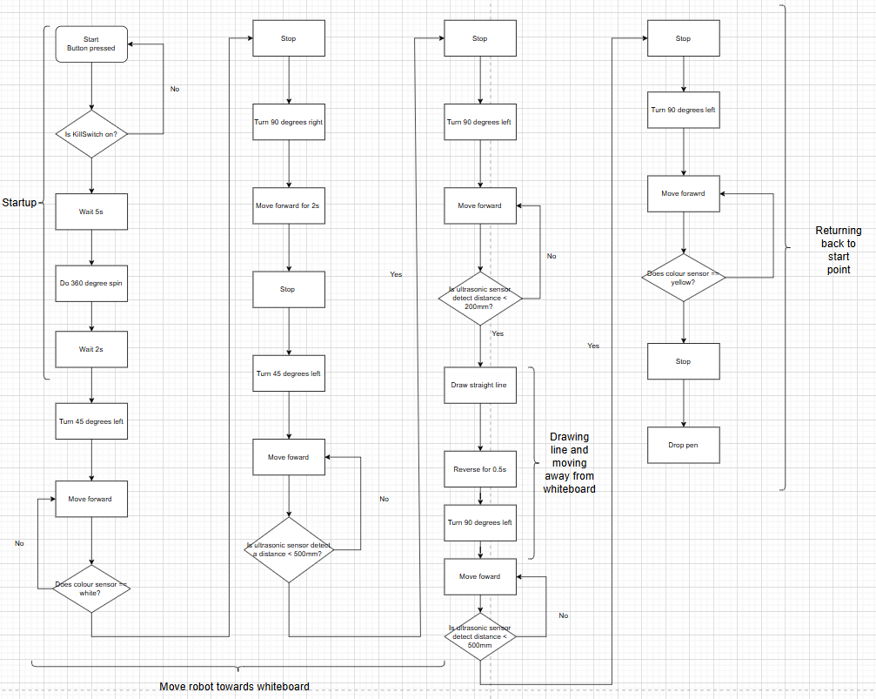
Fig. 4. Flowchart of the operational logic / main algorithm for Task 3.

Our arm consisted of two joints: θ1 (the shoulder) and θ2 (the elbow). The corresponding links are as follows: L1 (length of shoulder joint to elbow joint), L2 (length from elbow joint to penholder) and h (the vertical distance between the elbow and the base).
We found the position of the penholder (X_EE, Y_EE, Z_EE) by using standard forward kinematics:
- X_EE=L​1*cos(​θ1)+ L2*​cos(θ1+ θ2)
- Y_EE= 0
- Z_EE=h + L1*sin(​θ1)+ L2​*sin(θ1+ θ2)

Since the arm was constrained to a vertical plane, it is equal to zero. The arm is moved as a set of waypoints that are updated every 175ms. To make sure we get smooth motion and avoid abrupt actuation, we applied a rate limiter of (Δθmax) that was equal to 0.02 rad per control interval.

Using this, we created a visual representation of the inverse kinematics of the arm on desmos

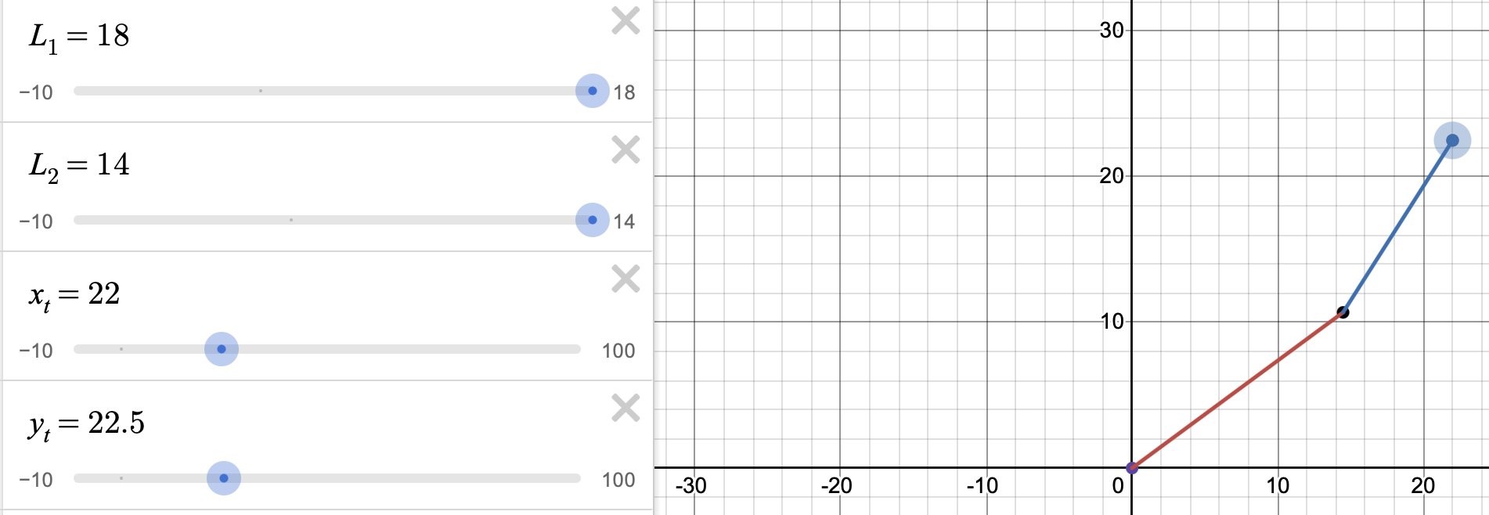
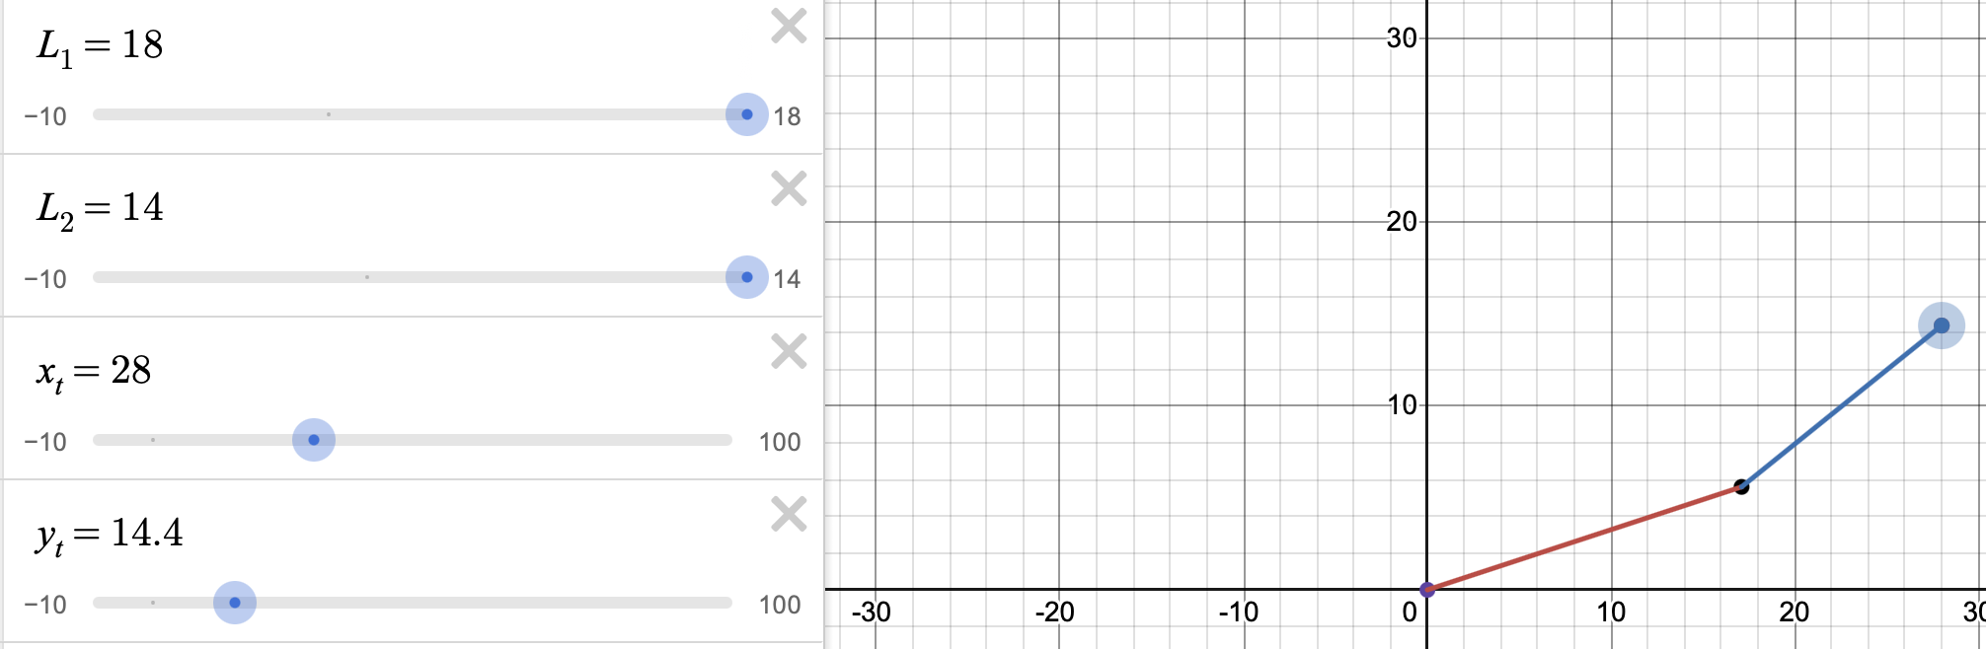

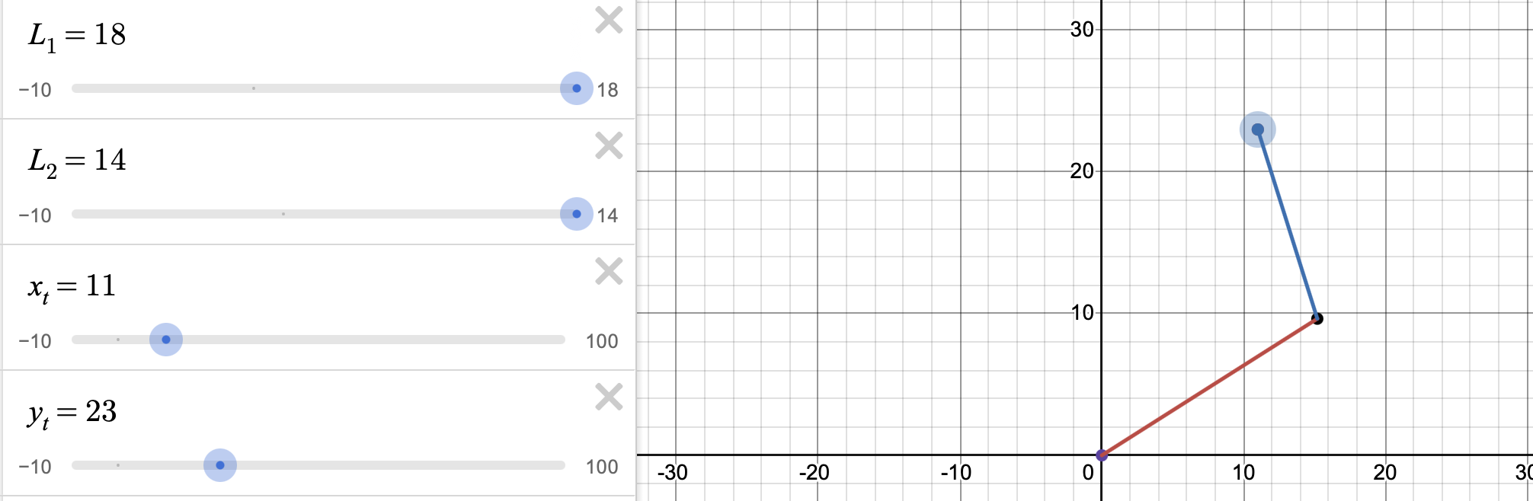

L1 = distance from pen tip to elbow joint (cm)
L2 = distance from elbow joint to shoulder joint (cm)
xt = horizontal target coordinate
yt = vertical target coordinate

Because desmos uses a 2d graph, y is used as the vertical dimension. We then converted this to align with our 3d kinematics equations to map the robot.

6 AVANCED MECHANISMS

During the testing stage of our robot's design we discovered that one wheel rotated faster than the other, therefore we designed a control feedback loop to counteract this. After implementation both wheels rotated at the same speed, This is the code we designed within our wheel turn functions:

//PID wheel speed control
error = encCount1 - encCount2;
correction = Kp * error;

rightWheelSpeed = baseSpeed - correction;
leftWheelSpeed = baseSpeed + correction;

Appendix (it is preferable to fit the content within two pages, though not mandatory). You may remove the explanatory text, retaining only the tables filled with the requisite information.

Example Table 1: Mechanical and electronic components and material list Any broken links will be treated as undefined items, resulting in a reduction of marks.

Item | Quantity | Price per item (university prices) | Total price | Total weight (g) | Total current (A)/power (W) consumption | link | Labels for fig 1:
batteries | 6 | 2.00 | 12.00 | 39.3 | 1.2 / 0.7 | link | B
holder | 2 | 1.50 | 3.00 | N/A | N/A | link | B
motor wheels | 2 | 1.85 | 3.70 | 60.0 | N/A | link | D
marker pen | 1 | 0.10 | 0.10 | 18.0 | N/A | link | N/A
button switch | 1 | 1.00 | 1.00 | N/A | 0.5 / 0.0 | link | N/A
toggle switch | 1 | 2.30 | 2.30 | N/A | 5.0 / 0.0 | link | C
arduino Mega | 1 | 0.00 | 0.00 | 37.0 | 0.45 / 1 | link | M
HC-SR04 ultrasonic sensor | 1 | 2.50 | 2.50 | N/A | 0.015 / 0.075 | link | I
TCS3200 colour sensor | 1 | 6.10 | 6.10 | N/A | 0.035 / 0.175 | link | J
ball casters (1/2 inch) | 2 | 1.80 | 3.60 | 4.0 | N/A | link | L
Male header pins (row of 12) | 2 | N/A (included in kit) | N/A | N/A | N/A | link | N/A
jumper wires | 44 | N/A (included in kit) | N/A | N/A | N/A | link | N/A
Motor Driver - Dual TB6612FNG | 1 | N/A (included in kit) | N/A | N/A | 1.2 / 7.2 | link | N/A
Servo Motor - MG996R (Metal Gear) | 1 | N/A (included in kit) | N/A | 55 | 0.7 / 4.0 | link | E
SG90 9g Micro Servo | 1 | N/A (included in kit) | N/A | 9.0 | 0.15 / 0.85 | link | F
FIT0450 gear motors | 2 | N/A (included in kit) | N/A | 100.0 | N/A | link | N
breadboards | 2 | N/A (included in kit) | N/A | 76.0 | N/A | link | K
printing material for robot arm (PLA plastic) | N/A | N/A | N/A | 115 | N/A | link | H/G
MDF (300x300, 4mm) for the chassis | 2 | 0.90 | 0.90 | 296.03 | N/A | N/A | A
 |  |  | Final total = £35.20 | 809.33 | 9.25 / 14

Example Table 2: Outsourced design/library/software materials
Autodesk Fusion | We used this software for the design of the pen holder, servo bracket and chassis | link
Cirkit designer | This was used for our circuit design | link
Desmos | This was used to generate values for the kinematics | link
Draw.io | We used this to create the flowchart | link
Excel | This was used for the costings of the robot

Reflection on Group Project

As a group we faced many challenges across the weeks we worked on this project including problems with both hardware and software. We started with some group members learning CAD to get the first initial design of the robot. We agreed as a team that the design was good. While one team was designing the robot, we had another working on tinkercad to get an idea for how our wiring was going to work. Once all the design was done we used 3D printers and laser cutters to assemble the vehicle. We learnt how to connect and program an ultrasonic and colour sensor to an arduino. A problem we faced was that the wheels would turn a different number of degrees each time we ran the code during our 360 degree turn. We solved this issue by using encoders and by changing the wheels and motors. We didn’t have any problems with coordination or organisation. We then finally got the complete robot ready for the demonstration where we all were prepped to answer any questions given to us by the examiner.

Alexander King

Starting with the hardware side of things, my main focus for this project was towards designing the whole robot arm including base, arm joint and pen holder all using fusion. I 3D printed these designs to build our robot arm and mounted it to the chassis. Additionally I did a large portion of the car’s wiring, which mostly consisted of wiring up the servos, wheel gear motors and wiring the motor driver. As for the software side of the project, I was tasked with coding the robot arm draw sequence, the wheel encoders, and a control feedback loop for the wheels so that they rotated at the same speed (one gear motor was slightly slower than the other). I also developed my groupmate’s initial circuit design, using Cirkit Designer software, creating our group's fully developed circuit. This project has helped me develop lots of new skills such as fusion design and allowed me to improve my independent engineering skills. My group and I have worked well together and I am happy with what we produced.

